Name: Suying Tu

ID: 33095213

Lab: Wednesday 4pm

Tutor: Frank Fan

URL: <https://stuu0004-monash.github.io/FIT3179-Week9HW/>

Screenshot:

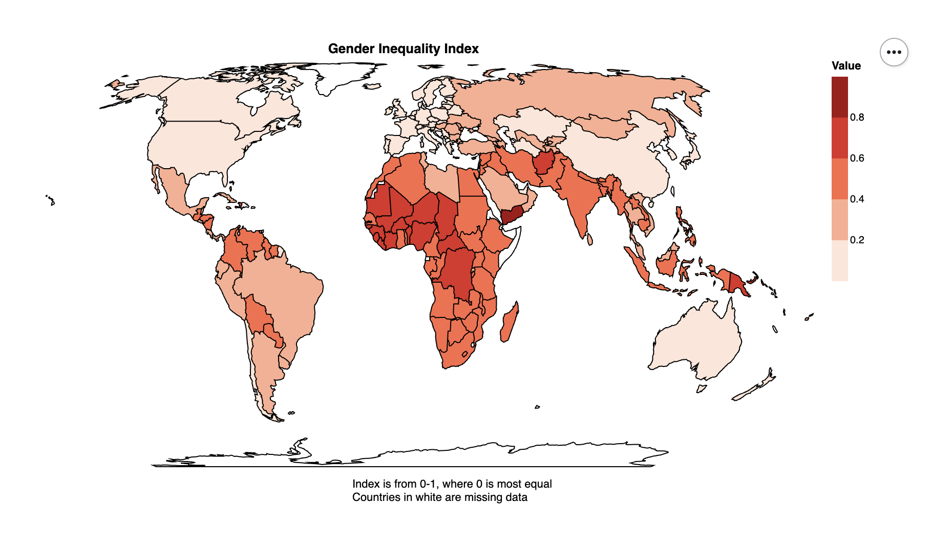

Domain: Gender Equality

Visualised Dataset:

* Gender Inequality Index by Country
* Source: <https://hdr.undp.org/data-center/thematic-composite-indices/gender-inequality-index#/indicies/GII>
* Attribute Types: Quantitative (for index)
* Author: United Nations

Data transformation/normalisation: None

Justification: I chose to use a choropleth map as the data varies according to countries (political borders).